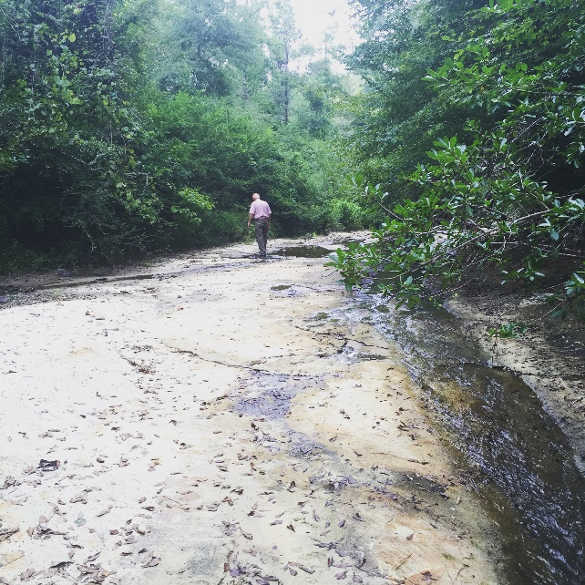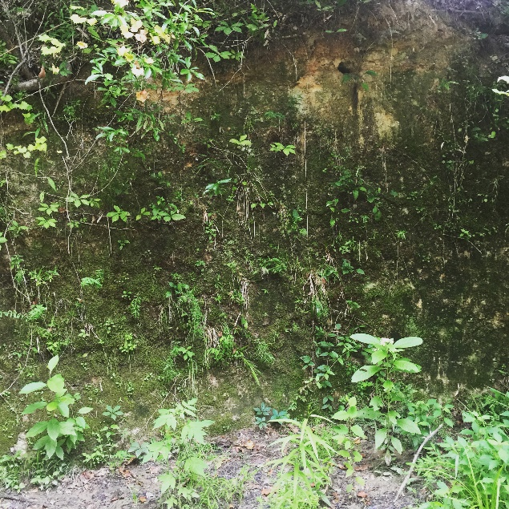
“Red Creek Walks with My Father: dyptych 01” | 2018
TAKE ME TO YOUR RIVER…TIME WITH MY FATHERS
“Take me to your River…Time with my Fathers” is a body of work created over the past seven years that reflects upon my journey in recovery. The work is a series of meditative moments recorded through image, sound, drawing, and artifacts. The work is not about technical perfection of a medium, process or decorative objects as “art”, but rather an introspective archive of images, sounds, drawings and assemblages of fleeting, meditative moments. Specifically, my own spiritual experiences through the power of water, light, sound, and the symbolic artifacts elevated to treasured talismans.
The title, ‘Take me to Your River’ is a line from a song about redemption by Leon Bridges titled “River”. And ‘Time with my Fathers’ refers to my time spent with God through prayer and meditation and the six months I spent with my Father in 2018 while living and renovating a cabin at Crooked Oaks. Both relationships were mended and created an emotional serenity through meditative moments in nature. Images and sound are from my time at Pavillon Treatment Center and its property of serene creeks and falls, my time in Delray Beach where I lived near the ocean, and my time on the farm walking along Red Creek with my father or simply watching the summer rain. The AA meeting drawings are sketches of coral I collected along the beach. These meditative exercises were daily practices while I listened to fellow AA travelers’ stories. The symbolic artifacts reflect memories of sacred healing routines and devasting loss.
This exhibition is dedicated to my father, Patrick Fain Dye [1939-2020] and my brother, Wayne Barrett Dye, [1966-2023] and to all those who are struggling with alcoholism. 30% of all sales will be donated to Pavillon Treatment Center, The AA Crossroads Club of Delray Beach Florida, and The Crooked Oaks Legacy Foundation. The exhibition will be at Opelika Art Haus located at 500 N Railroad Avenue, Opelika, Alabama. Opening reception will be Saturday August 26th from 5-8 pm. Viewing hours are Saturday from 11 am – 8 pm and Sunday from 11 am - 5 pm.
Wanda Ward Dye is an award-winning Architectural educator and has worked in academia, art, and architecture for over 25 years and was the founding director of RE gallery in Dallas, Texas for over 5 years. She received her Architectural degrees from Columbia University and Auburn. Presently she works for a small business organization and continues her creative practice in her spare time. To view an archive of her academic, curatorial and art practices visit www.dye-projects.com. For all inquiries email contact@dye-projects.com.

